Problem B

Raphael Dizon

2024-01-24

# Data Cleaning and Processing

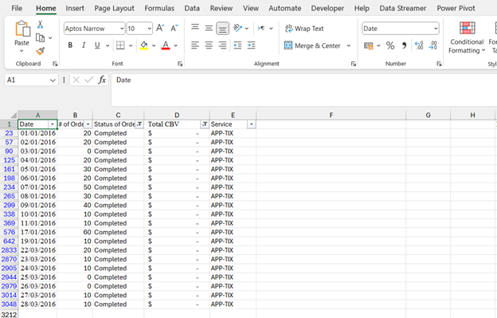

Removed rows that have a “Status if Order: Completed” but has no Total CBV, because it will affect the integrity and analysis of data.

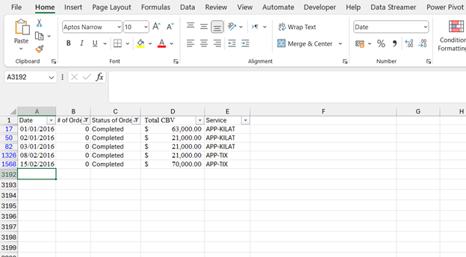

Also removed rows with “0” # of orders but has completed, canceled, no drivers found, and Other/Failed/Timeout status because it will skew the analysis of data and create confusion because there’s no basis of the CBV.

In the case of Other/Failed/Timeout: Bug in the system with 0 values on # of orders. Its somewhat relevant to the analysis of data.

After removing irrelevant rows for data analysis, there were 2,769 rows left from the original uncleaned data of 3,211. A total of 442 rows removed.

After that I replace blank values in the Total CBV column and replace it with the value 0, in order to create analysis and visualization.

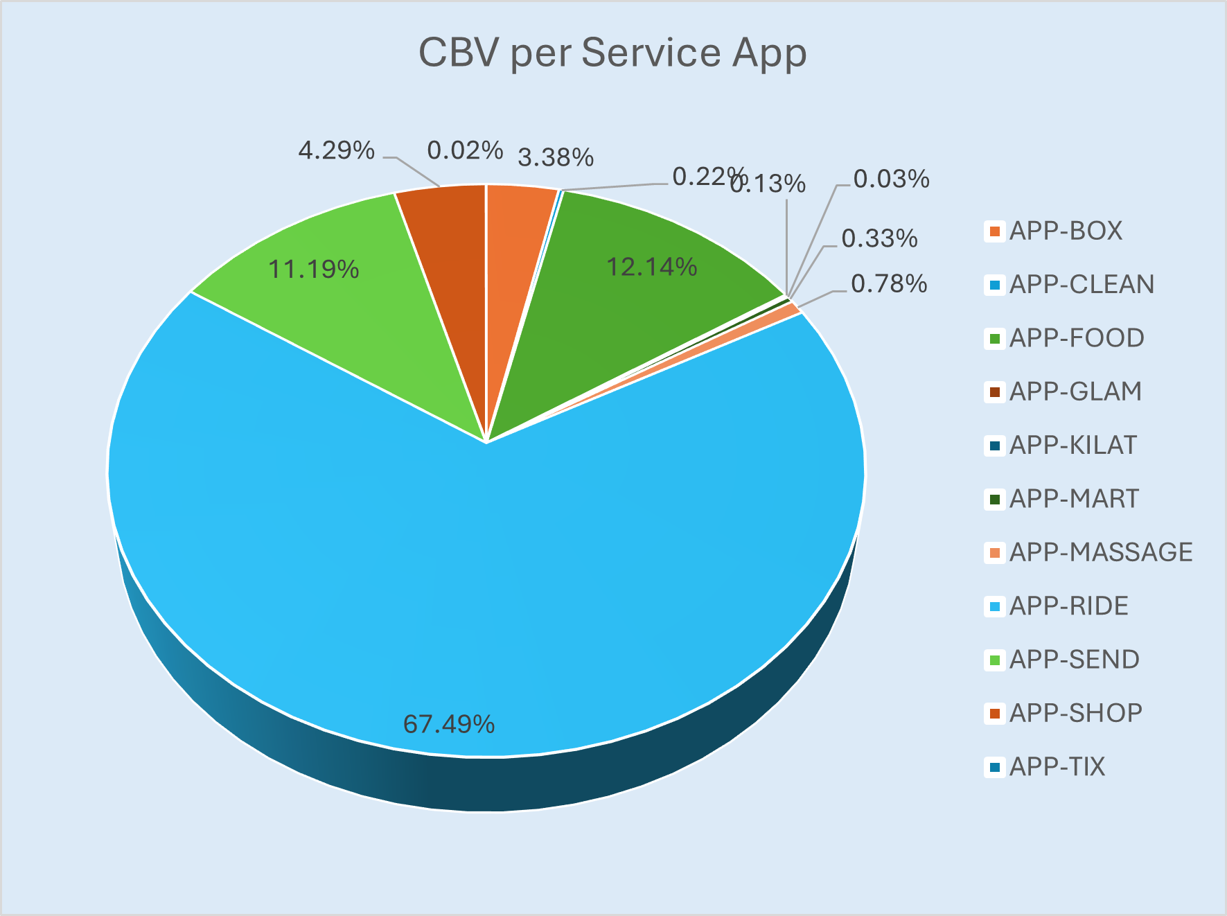

In this pie-chart shows the sum total Cash booking value per Service app in percentage, where App-ride has produced the highest from the data.

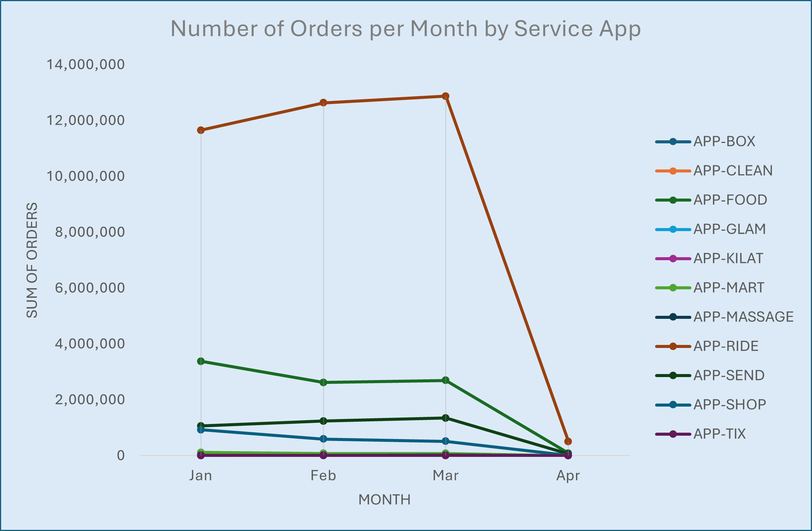

In this line chart highlights the total number of orders per month by service app, It shows that theirs is an increasing trend from the first quarter and a huge drop on the start of 2nd quarter.

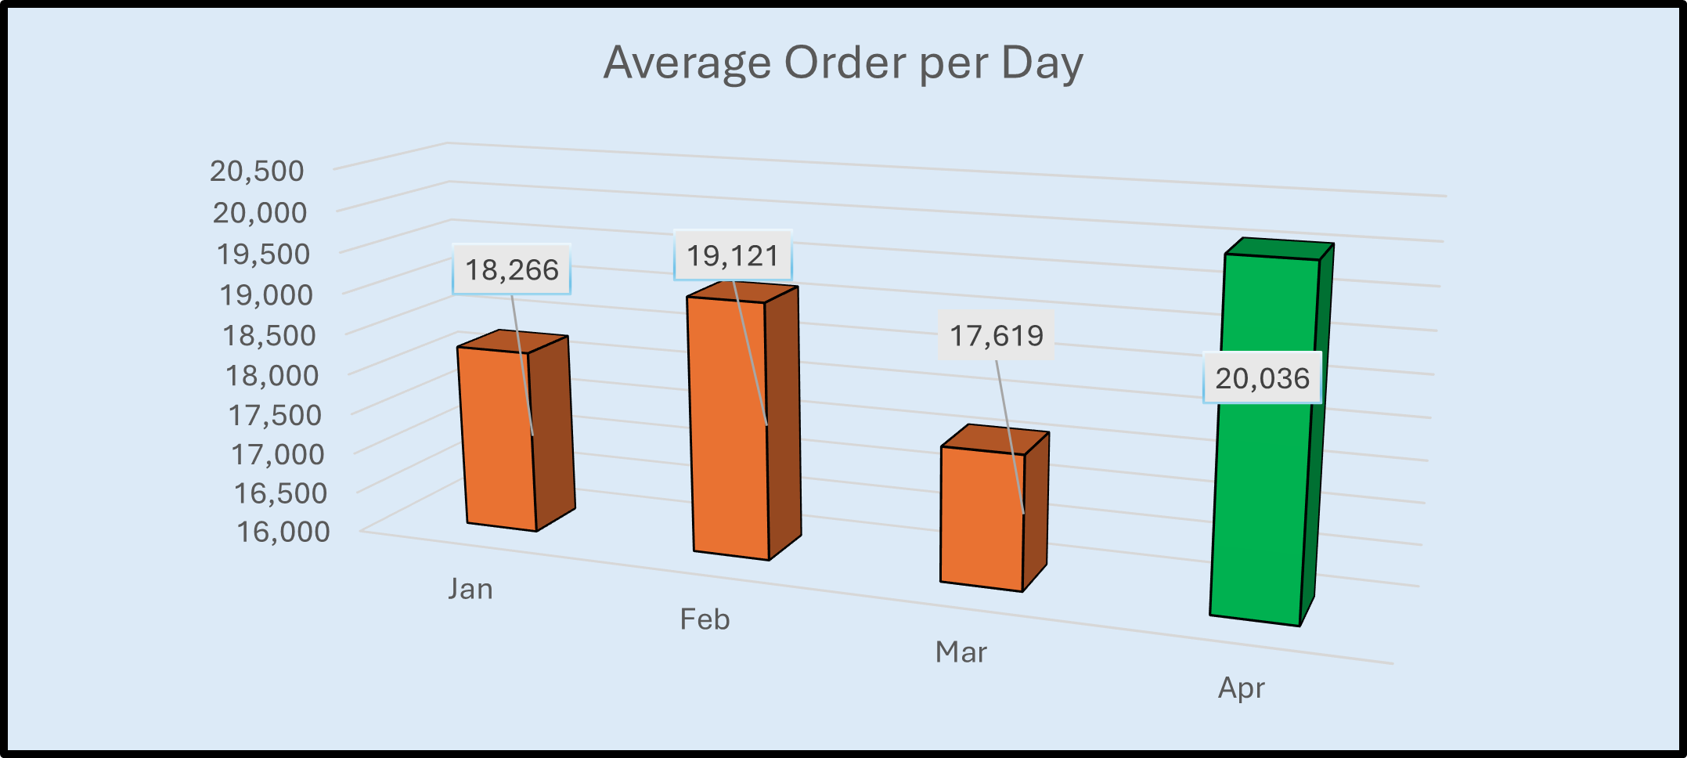

In this Bar-chart, It highlights the average order per day inclusive of any status of order whether completed, canceled, no drivers found, and Other/Failed/Timeout status.

However, for April there is only 1 day recorded which means there are still data that going to be added and be included in the analyzation process.

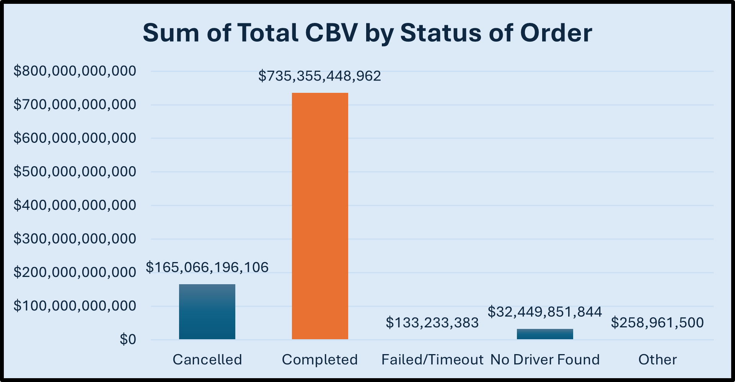

In this Bar-Chart, shows the total sum of Cash Booking values from the various Status of orders. Looking at a business perspective, potential CBV Loss can be analyzed if we take the total values from Cancelled, Failed/Timeout, No Driver Found, and Other which approximately $197 Billion.

In addition to visually analyze the data, I added a slicer to further see specific values from the Status of Orders.

***Insights:***

1. In the pie chart, the most utilized APP was the APP-Ride. With about 67.49% compared to other apps
2. In the line chart, there an increasing trend on the number of orders and surely see that the next quarter will project better numbers.
3. Taking the average order from the first quarter, shows quite good results. However for April, it has a pleasing good start, but needs to be consistent and maintained.

***Summary:***

• With the results of the data it illustrates a consistent and substantial increase in the number of orders placed through our platform over the past quarter.

• This upward trajectory is indicative of a growing demand for our services, presenting a strategic opportunity for expansion.

***Recommendation:***

• Develop and Implement an Action Plan. Since there is a good standard that is on the trend of the data it’s important to scale on the next steps.

• Strengthen data analytics capabilities to extract deeper insights into user behavior, preferences, and market trends. Utilize these insights for informed decision-making and strategic planning.

• Establish an enhanced and systematic customer feedback mechanism as it is the metric that drives order completion rates among the APPS.

***Commitment to the next quarter and to long-term goals:***

• Initiate and Intensify the utilization of all the Apps that are used by increase marketing efforts to leverage the positive trends.